Order listing for 4 panels-center opening door operator

Buyer： |  |  |  |  |  |  | Order： |  |  |  |  | Date：
№ | Type |  |  | Name |  | Unit |  | Qty |  | U/P | Amount |  |  | Remark
1 | THP131-29 |  | /JJ2100 | Car door operator |  | set |  | 4
2 | JMB331-27 |  | /JJ2100 | Car door panel |  | set |  | 4
3 | M49216.01-05 |  | /JJ2100 | Car door sill |  | pc |  | 4
4 | ACB141-26 |  | /JJ | Safety edge |  | set |  | -
5 | THP161-27 |  | /JJ2100 | Landing door device |  | set |  | 16
6 | CMB375-27 |  | /JJ | Landing door panel |  | set |  | 16
7 | NS371027C001 |  | /JJ2100 | Landing door sill |  | set |  | 16
8 | MTP361-28 |  | /JJ2100 | Small jamb |  | set |  | 16
9
10
11
12
13
14 | 合 计
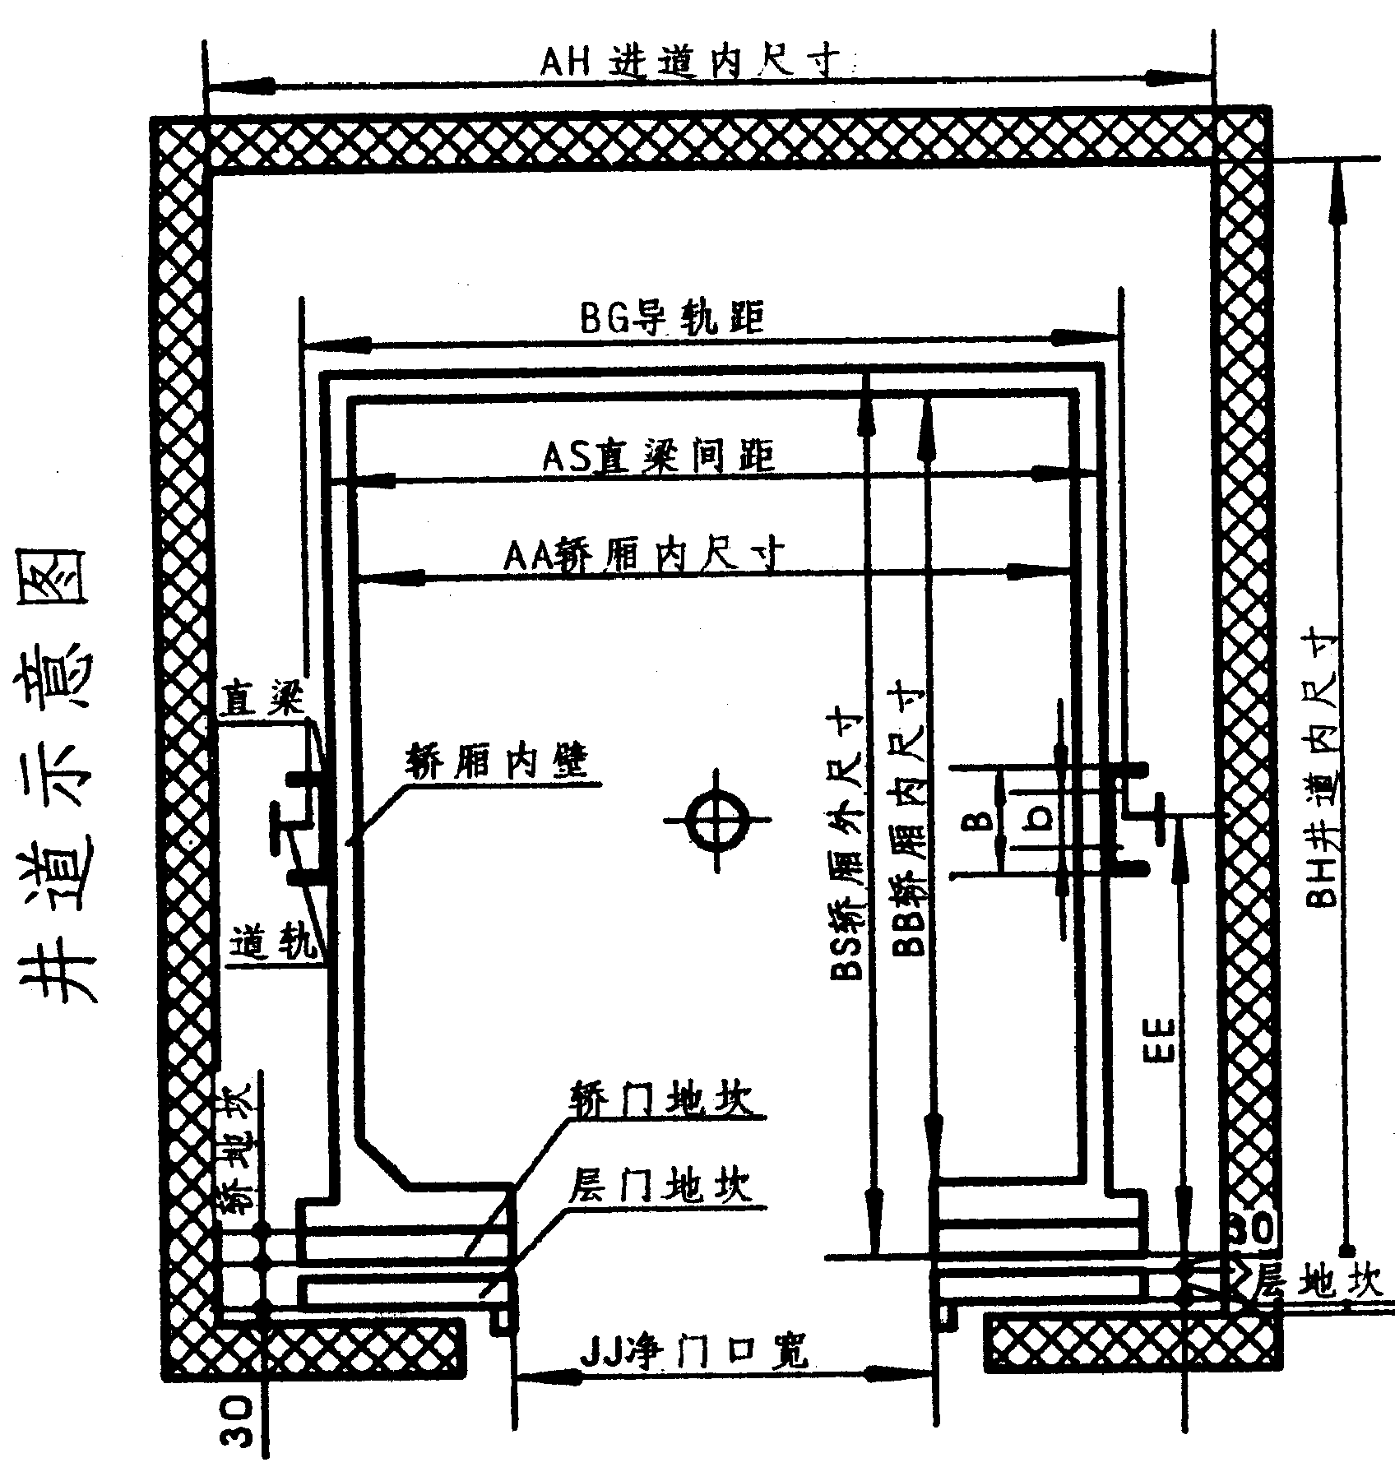 |  |  |  |  | Net opening width |  |  |  |  |  |  |  |  | JJ=2100
 |  |  |  |  | Net opening height |  |  |  |  |  |  |  |  | H=2100
 |  |  |  |  | Distance from car sill to center of upright |  |  |  |  |  |  |  |  | EE=
 |  |  |  |  | Width of both sides upright |  |  |  |  |  |  |  |  | AS=
 |  |  |  |  | Height from sill to tope of cross head |  |  |  |  |  |  |  |  | HB=
 |  |  |  |  | Distance from upright to hole of transverse rod |  |  |  |  |  |  |  |  | b=
 |  |  |  |  | Width of car frame upright |  |  |  |  |  |  |  |  | B=
 |  |  |  |  | Please choose the type of upright
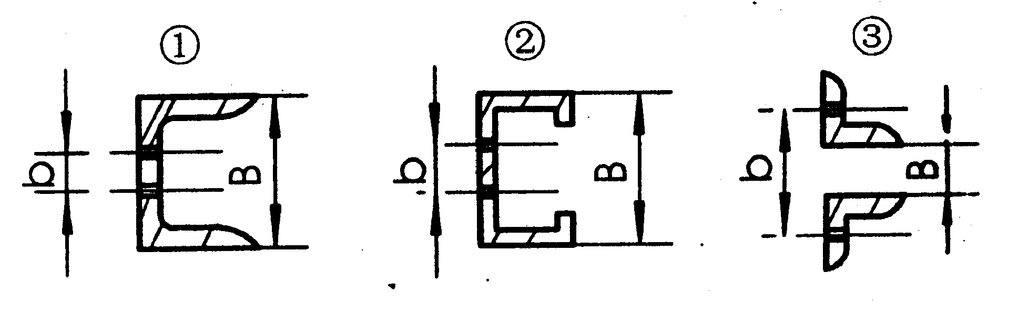
Please inform if you have another requests：
Explain：Above technical data was provided and confirmed by buyer
29 Type is VVVF operator，the width of sill is 125(car door sill ), 112(landing door sill)
If you need cast iron sill, please remakes NB1210C094 (car door sill), NB3710C080 (landing door sill)
Door panel is including with pipe, rubber door edge and aluminium strip
Please indicate color when panel and jamb are painted

Signature by buyer： Alaa M Ali Signature of seller： Assess by seller：

NINGBO SHENLING LIFT ACCESSORIES CO.,LTD TEL：（0574）65977789FAX：（0574）65962000

