Canlift CL-07
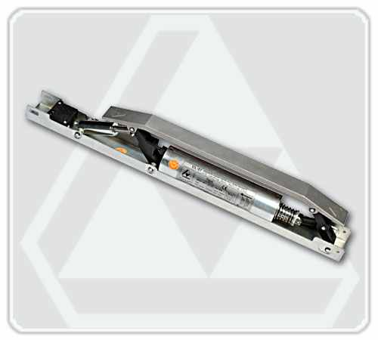
CL-07
Lift Landing Door Retering Cam
» High quality and with technical features,
» Convenient assembly and hardness,
» Special packaging to protect against outer factors enabling easy storage,
» 33 mm. mobility zone
» Voltage : 48, 60, 80, 110, 190 V. DC 220 V. AC
» Bobbin Rotation / Hour : 240
» Weight : 5,5 kg.
» Two year actual guarantee.
Technical Drawing
