DK-05
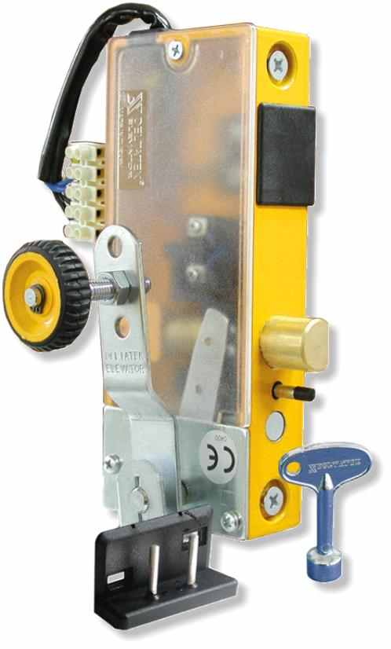
*ALL PLASTIC PARTS ARE PRODUCED IN OUR INJECTION MACHINERIES FROM ORIGINAL RAW MATARIAL
*ALL METAL PARTS ARE PRODUCED ON OUR C.N.C MACHINERIES
*2 YEAR REAL GUARANTEE FOR PRODUCTION FAULTS
*WE TEST OUR PRODUCTS FOR LİFE, ELECTRICITY AND STRENGTH PERIODICALLY IN OUR LAB.
*IF NEEDED WE ALSO PRODUCE LOCKS FOR DOUBLE WING DOORS
*MAX. OPERATING VOLTAGE 240 VOLTS AC, 0.25A
OUR PRODUCTS HAVE T.S.E.K CERTIFICATES
*OUR PRODUCTS HAVE CE CERTIFICATES

