Monochrome LCD position indicator CM300 CM540
The CM300, CM540 monochrome LCD display is a good value; innovative and visually attractive lift indicator display that was developed to provide a high-tech looking alternative to normal dot matrix displays.
The CM300, CM540 comes in two color combinations, eye-catching Green on yellow, and contrasting dark gray on white.
The display comes in two orientations, vertical and horizontal, each with their own advantageous features.

Features
• Slim line, Low Profile, Small Size and Compact.
• Able to show lift positions, directional arrows
• Bright Green on yellow or contrasting dark gray on white
• Configuration of floor legends and arrow can be programmed into an EEPROM
• Can be horizontally or vertically mounted

Applications
• Use as car position indicator on car operating panel
• Hall position indicator on hall landings
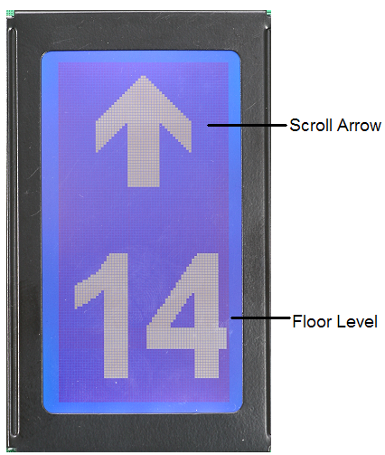

Display Specification
Interface | One wire serial
Display Type | Monochrome STN LCD
Effective Viewing Area (mm) | 66 (W) x 33 (H)
Physical Product Size (mm) | 70 (W) x 140 (H) x 16 (D)
Resolution (pixels) | 128 x 64
Dot Size | 0.48 x 0.48 mm
Dot Pitch | 0.52 x 0.52 mm
Viewing Angle X-axis For Landscape | -30°to +30°
Viewing Angle Y-axis For Landscape | 5°to +30°
Floor Legend and Arrow Height (variable) | Typically 40mm
Character Height for Messages (variable) | Typically 7mm
Absolute Maximum Ratings
Supply Voltage, DC | 12V to 30V
Supply Voltage, AC | 10V to 27V
Supply Current @ 12V DC | 0.3A
Supply Current @ 24V DC | 0.2A
Signal Voltage, DC (opto isolated input type) | 10V to 30V
Signal Current, DC (opto isolated input type) | <10mA
Operating Free-air Temperature Range | 0℃——50℃
Storage Temperature Range | -20℃——70℃
Humidity | 10% to 90% non condensing
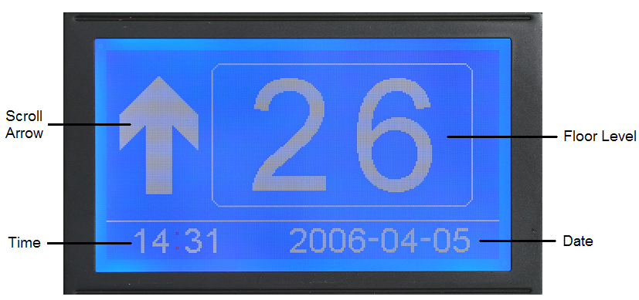

Features
• Slim line, Low Profile, Small Size and Compact.
• Able to show lift positions, directional arrows, date , time and simple messages
• Bright Green on yellow or contrasting dark gray on white
• Configuration of floor legends and arrow can be programmed into an EEPROM
• Can be horizontally or vertically mounted

Applications
• Use as car position indicator on car operating panel
• Hall position indicator on hall landings

Display Specification
Interface | 12 inputs/RS485, RS232/7-SEG,  Binary, BCD, Gray code et.
Display Type | Monochrome STN LCD
Effective Viewing Area (mm) | 108 (W) x 58 (H)
Physical Product Size (mm) | 144 (W) x 130 (H)
Resolution (pixels) | 240 x 128
Dot Size | 0.4 x 0.4 mm
Dot Pitch | 0.45 x 0.45 mm
Viewing Angle X-axis For Landscape | -30°to +10°
Viewing Angle Y-axis For Landscape | 10°to +40°
Floor Legend and Arrow Height (variable) | Typically 36mm
Character Height for Messages (variable) | Typically 7mm
Absolute Maximum Ratings
Supply Voltage, DC | 10V to 30V
Supply Voltage, AC | 10V to 27V
Supply Current @ 12V DC | 0.5A
Supply Current @ 24V DC | 0.3A
Signal Voltage, DC (opto isolated input type) | 10V to 30V
Signal Current, DC (opto isolated input type) | <10mA
Operating Free-air Temperature Range | 0℃——50℃
Storage Temperature Range | -20℃——70℃
Humidity | 10% to 90% non condensing

Full Color LCD position indicator CM840 (developing)
The CM840 full color displays not only provide standard information like position, directional arrow, date, time, and messages, but also time-based pictures and messages.
Using active matrix TFT, the displays provide a high-resolution effect. They are available in 8.4”, 10.4” screen sizes.
