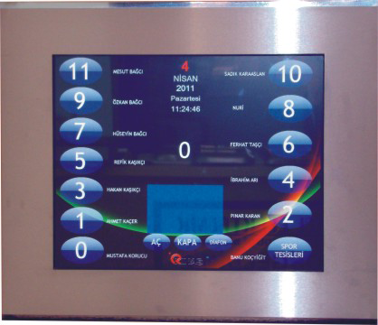
T-100 TOUCH PANEL CAR
-XML-BASED FLEXIBLE DESIGN
EXECUTIVE PANEL WITH EASY-CHANGE OF NAME AND PICTURE
-LIFT USE Statistics,
-REMOTE DESKTOP CONNECTION
-VISUAL INFORMATION CIRCULAR
-STANDARD DESIGN COMPONENTS
-Adobe Flash (SWF)
-Image formats (png, gif, bmp, jpg, jpeg, wmf)
-Video formats (avi, mpeg)
-RSS (xml-based providers of news, weather and current which potcastler internet)

