CENTA - RS2
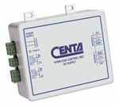
Load Measuring System For Wire Ropes
• Mecanical Capacity
• Quantity of programmable Outputs :2
• Very easy to install
Mechanical Information To Click
