8001

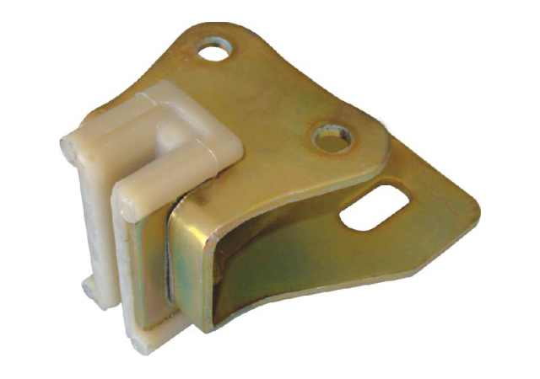

|  |  |  |
| --- | --- | --- |
| |  |  | | --- | --- | | **FEATURES** |  | |
| |  |  |  |  |  |  |  | | --- | --- | --- | --- | --- | --- | --- | | |  |  | | --- | --- | | • | 4 mm galvanized sheet | | • | Polyamide guide shoe | | • | 2 types for guides 5-9mm | | |

**Technical Drawing**

[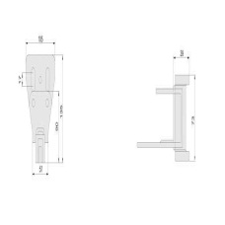](http://dapsan.com/uploads/8001CZM.jpg)