SKYGO2
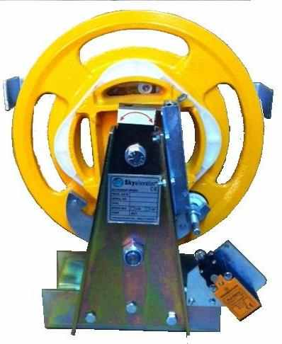
FEATURES
• Fullfillment of lift directive 95/16/EC (EN 81-1 81-2)
• Engaging of the safety gear in both directions
• First cuts off the safety switch and than trips
• Overspeed governor with safety contact
• Configuration for machine room or shaft head possible
• Tensioning weight with safety contact
• Applicable for secondary installations and modernizations
• Pre-set according nominal speeds and sealed
• Fixing holes are completely compatible with other overspeed governors
• Mounting at almost everry lift type possible
• Easy installation and maintenance
• Test groove
• Detailed operating instructions
• Optional remote control unit
• Optional encoder ( Shaft Dia Ø 6-8 mm and Rabbet Dia Ø 30 mm )
PRODUCT DIMENSIONS
